PUREPOWER FUEL CONDITIONING TABLET
(A COMBUSTION CATALYST IN SOLID FORM)
10 DUEL FUEL TREATMENT TABLETS
ONE TABLET TREATS UP TO 60 LITRES PETROL / DIESEL.

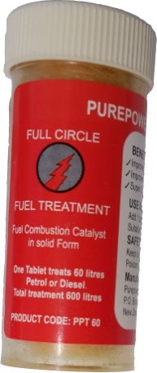
USER INSTRUCTIONS.

FIRST TREATMENT:

Add 2 tablets to Petrol or Diesel tank for up to a 60 litre fill.
Follow up treatments: add 1 tablet for each 60 litre fill.
Tablets can be broken into quarters to accommodate smaller tank fills.
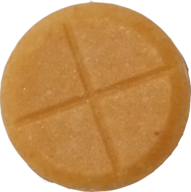
Up to 15 litres. ¼ tablet
Up to 30 litres. ½ tablet
Up to 45 litres. ¾ tablet
1 Tablet
treats
60 litres

Up to 60 litres. 1 tablet.

10 Tablets treat
600 litres Petrol
or Diesel

Continuous treatment is recommended to achieve maximum benefits.

KEEP OUT OF REACH OF CHILDREN.
STORE IN COOL PLACE & OUT OF DIRECT SUNLIGHT

Manufacture in NEW ZEALAND by:
Purepower Fuel New Zealand Limited. 33 Swan Crescent, Pakuranga Auckland
P.O. Box 58-701 Botany Auckland Telephone +64-21-02379870/+64-21-992147
Email purepowerfuel@yahoo.com

