PUREPOWER FUEL CONDITIONING TABLET
(A COMBUSTION CATALYST IN SOLID FORM)
6 DIESEL FUEL TREATMENT TABLETS
ONE TABLET TREATS UP TO 200 LITRES DIESEL.

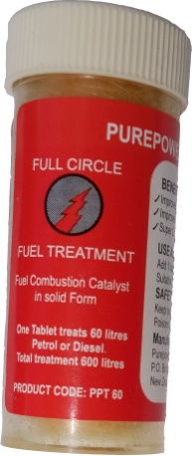
USER INSTRUCTIONS.

FIRST TREATMENT:

Add 2 tablets to Diesel tank for up to a 200 litre fill.
Follow up treatments: add 1 tablet for each 200 litre fill.
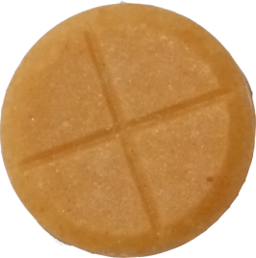
tank fills.

1 Tablet
treats
200 litres

6 Tablets treat
1200 litres Diesel

Continuous treatment is recommended to achieve maximum benefits.

KEEP OUT OF REACH OF CHILDREN.
STORE IN COOL PLACE & OUT OF DIRECT SUNLIGHT

Manufacture in NEW ZEALAND by:
Purepower Fuel New Zealand Limited. 33 Swan Crescent, Pakuranga Auckland
P.O. Box 58-701 Botany Auckland Telephone021-992147
Email purepowerfuel@yahoo.com

